**INCIDENCE MATRIX FOR GRAPH REPRESENTATION**

**Introduction**

Graphs are powerful data structures used to model pairwise relationships between objects. One of the key ways to represent graphs is through an Incidence Matrix. This lecture will cover the purpose, use cases, description, storage, and provide pseudocode for implementing an incidence matrix.

**What is an Incidence Matrix?**

An incidence matrix is a way to represent a graph using a matrix where the relationships between vertices and edges are directly mapped.

**Details about the topic**

- **Matrix Structure**: The incidence matrix is a \(V \times E\) matrix, where \(V\) is the number of vertices and \(E\) is the number of edges.

- **Matrix Cells**: Each cell \(matrix[i][j]\) is 1 if vertex \(i\) is incident (connected) to edge \(j\), and 0 otherwise.

**Example**

Consider a simple graph with 4 vertices and 3 edges:

Vertices: 0, 1, 2, 3

Edges: (0-1), (1-2), (2-3)

The incidence matrix for this graph would be:

E0 E1 E2

0 1 0 0

1 1 1 0

2 0 1 1

3 0 0 1

**Now lets understand it by graphical representation:**

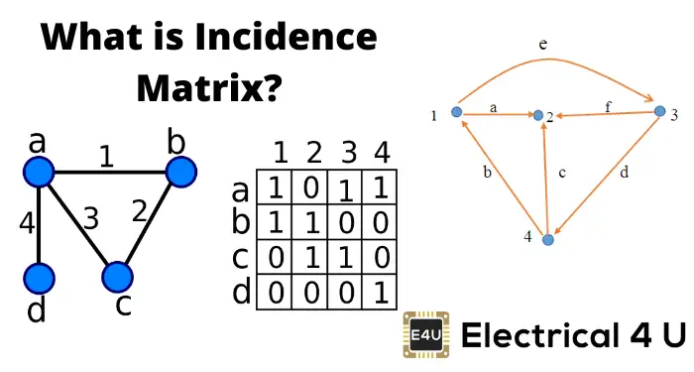

**What is the purpose and used case of this :**

**Purpose:**

The incidence matrix provides a straightforward way to represent which vertices are connected to which edges. This can be particularly useful in applications where edge properties are important or when performing certain types of graph analysis.

**Use Case:**

- **Graph Theory Analysis**: Useful for studying properties related to edges, such as in network flow problems.

- **Electrical Networks**: Incidence matrices are used in circuit theory to represent electrical networks.

- **Bipartite Graphs**: Effective in representing bipartite graphs where the two sets of vertices can be naturally split by edges.

**Storage**

**Storage Format**

- The incidence matrix is stored as a 2D array or matrix.

- **Space Complexity**: \(O(V \times E)\), which can be inefficient for large graphs with many edges and vertices.

**Pseudocode**

Let's walk through how you would implement a graph using an incidence matrix in a typical programming setup.

class Graph:

def __init__(self, vertices, edges):

self.V = vertices # Number of vertices

self.E = edges # Number of edges

self.inc_matrix = [[0 for _ in range(edges)] for _ in range(vertices)]

def add_edge(self, edge_id, src, dest):

if 0 <= edge_id < self.E and 0 <= src < self.V and 0 <= dest < self.V:

self.inc_matrix[src][edge_id] = 1

self.inc_matrix[dest][edge_id] = 1

def display_matrix(self):

for row in self.inc_matrix:

print(row)

**Usage**

vertices = 4

edges = 3

graph = Graph(vertices, edges)

graph.add_edge(0, 0, 1) # Edge 0 connects vertex 0 and vertex 1

graph.add_edge(1, 1, 2) # Edge 1 connects vertex 1 and vertex 2

graph.add_edge(2, 2, 3) # Edge 2 connects vertex 2 and vertex 3

graph.display_matrix()

**Explanation**

-**Initialization**: We initialize the graph with the number of vertices and edges, and create a \(V \times E\) matrix filled with zeros.

- **Adding** **Edges**: The `add_edge` method updates the incidence matrix to mark the vertices connected by each edge.

- **Displaying** **Matrix**: The `display_matrix` method prints the incidence matrix for visualization.

**Historical Context and Origins:**

The concept of incidence matrices is rooted in graph theory, which was formally introduced by the Swiss mathematician **Leonhard Euler** in the 18th century. Although Euler's work primarily focused on solving the famous **Seven Bridges of Königsberg** problem, it laid the groundwork for modern graph theory. The incidence matrix itself has become a fundamental tool in this field, used extensively in both theoretical and applied graph analysis.

**Applications in Real-World Scenarios:**

1. **Network Flow Analysis:** Incidence matrices are used to model and analyze flows in networks, such as transportation or communication networks.

2. **Circuit Design**: In electrical engineering, incidence matrices help represent and analyze electrical circuits, where vertices represent connection points (nodes) and edges represent electrical components (wires, resistors).

3. **Chemical Graph Theory**: Used to model molecules where vertices represent atoms and edges represent chemical bonds, aiding in the study of molecular structure and properties.

**Conclusion**

The incidence matrix is a powerful and versatile representation for graphs, particularly useful in scenarios where understanding the relationship between vertices and edges is critical. While it may not be the most space-efficient representation for very large graphs, its applications in various fields demonstrate its importance.

Understanding and implementing incidence matrices equips you with another tool in the arsenal of graph representation methods, enabling you to tackle a wide range of problems in computer science and beyond.